**HandsMen Threads: Elevating the Art of Sophistication in Men's**

**Project Overview**

HandsMen Threads, a vibrant player in the fashion space, is embarking on a journey to modernize how it manages data and connects with customers using Salesforce CRM. This project is all about building a flexible system that keeps information flowing smoothly, helps employees make better decisions, and strengthens customer relationships through intelligent automation.

**Objectives**

* Centralize and organize all customer and order-related data.
* Send customers automatic order confirmations to build trust and engagement.
* Keep the warehouse in the loop with early alerts for low stock.
* Validate data directly from the user interface to reduce errors.
* Run daily updates to ensure inventory and financials are accurate and up to date.

**Phase 1:Requirement Analysis & Planning**

**Understanding Business Needs**

We started by talking to users and stakeholders to understand the core challenges: scattered data, manual updates, inconsistent communication, and delays in stock management.

**What We Planned To Do**

* Create custom Salesforce objects like Customer, Order, Inventory, LoyaltyProgram, and WarehouseNotification.
* Use Salesforce automation tools like Flows and Apex Triggers to handle routine tasks.
* Build scheduled processes to handle bulk actions like inventory updates.

**How We Designed It**

* **Custom Objects**: Customer, Order, Product, Loyalty, WarehouseNotification, BulkOrderUpdate.
* **Object Relationships**: Customers are linked to their Orders (master-detail), and each Order references Products (lookup).
* **Security Setup**: Role hierarchy, Profiles, Permission Sets, and field-level security ensure the right data is seen by the right people.

**Phase 2:Salesforce Development - Backend & Configurations**

**Development Setup**

We worked in a sandbox environment and used Git for version control to track changes.

**What We Built**

* Created all objects and fields using the Object Manager.
* Added validation rules to ensure quality data entry (e.g., Order dates can't be in the past).

**Automations**

* **Flows**:
  + Automatically send confirmation emails when an order is placed.
  + Scheduled flows run every night to process and update bulk orders.
* **Apex Triggers**:
  + When a new order is created, update that customer's loyalty status.
  + When a product’s stock drops below five, notify the warehouse team.
* **Batch Apex**:
  + Used for processing bulk orders and updating financial records and inventory at midnight.

**Phase 3:UI/UX Development & Customization**

* Created a custom Lightning app called "HandsMen CRM."
* Designed intuitive Lightning pages and layouts with dynamic forms.
* Validation rules are enforced through the UI to guide users.
* Email templates set up for automatic communication with customers and internal teams.
* Built dashboards to track things like daily orders, stock status, and customer loyalty points.

**Phase 4:Data Migration, Testing & Security**

**Getting the Data In**

* Imported historical data using Salesforce Data Loader for Customers and Products.

**Security Measures**

* Assigned roles and profiles based on job responsibilities.
* Used permission sets for specific access needs.
* Enabled field history tracking for important data changes.
* Created rules to avoid duplicate customer records.

**Testing Our Work**

* Developed test classes for Apex code to ensure smooth operations (>85% code coverage).
* Created and ran test cases for:
* Order confirmations
* Loyalty point updates
* Stock alert workflows
* Nightly batch updates

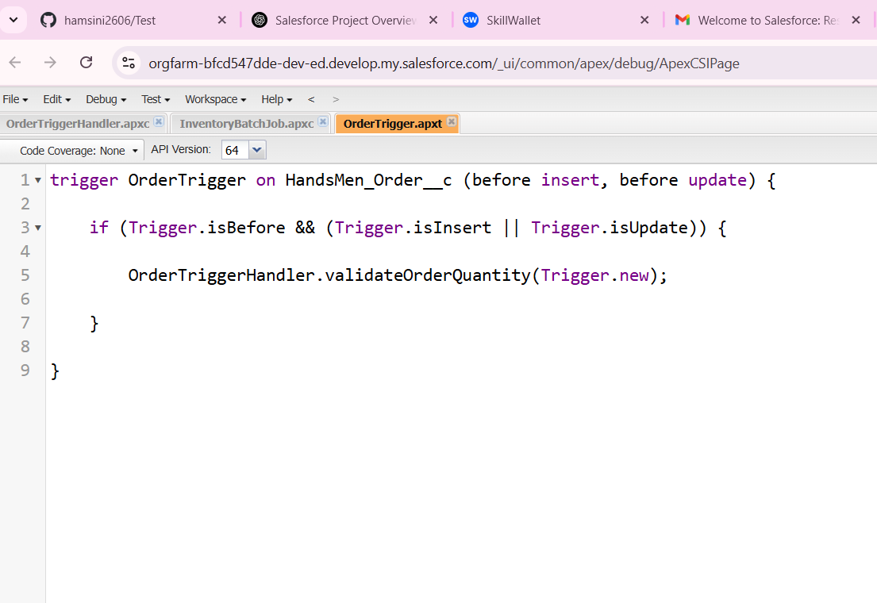.

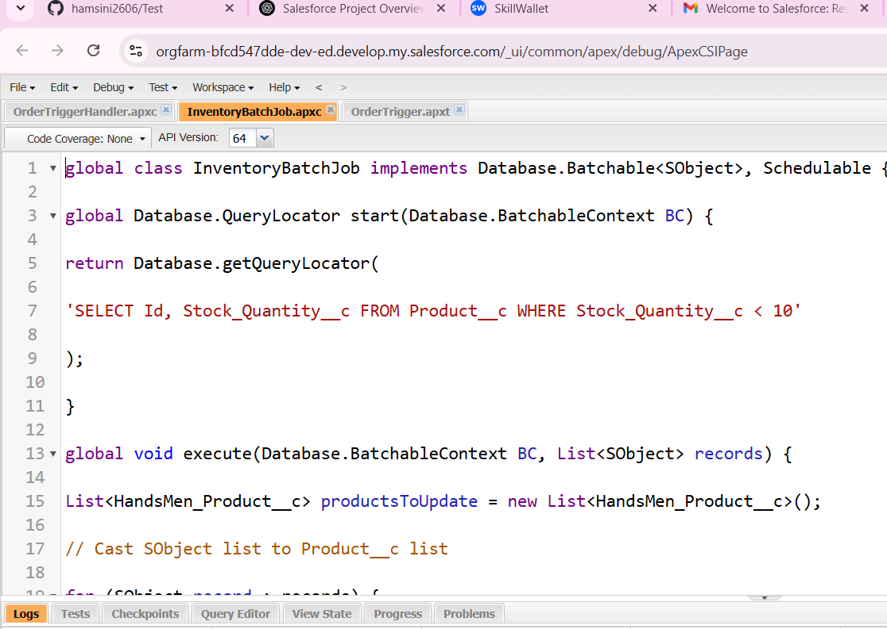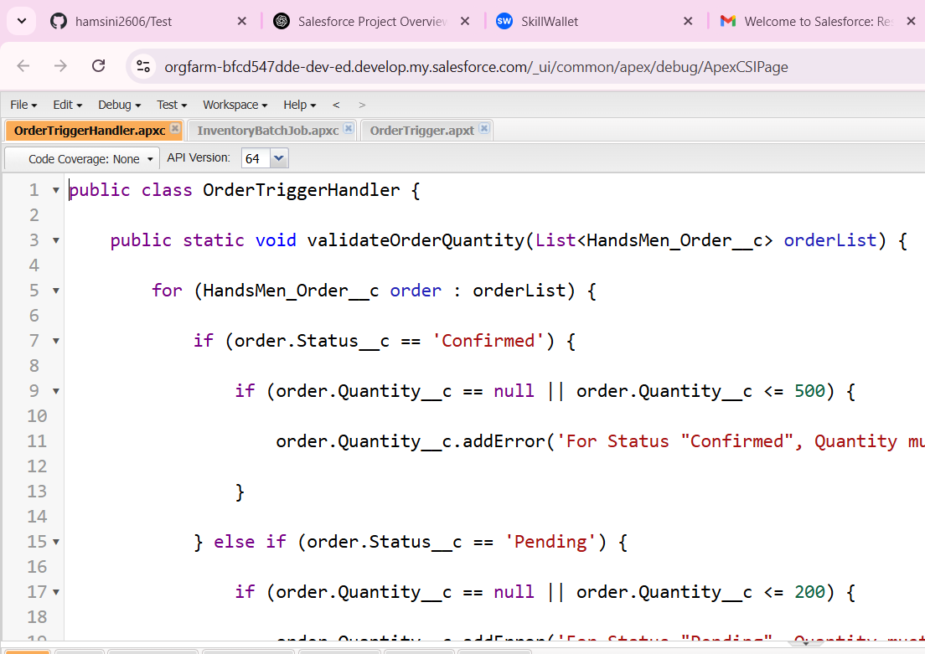

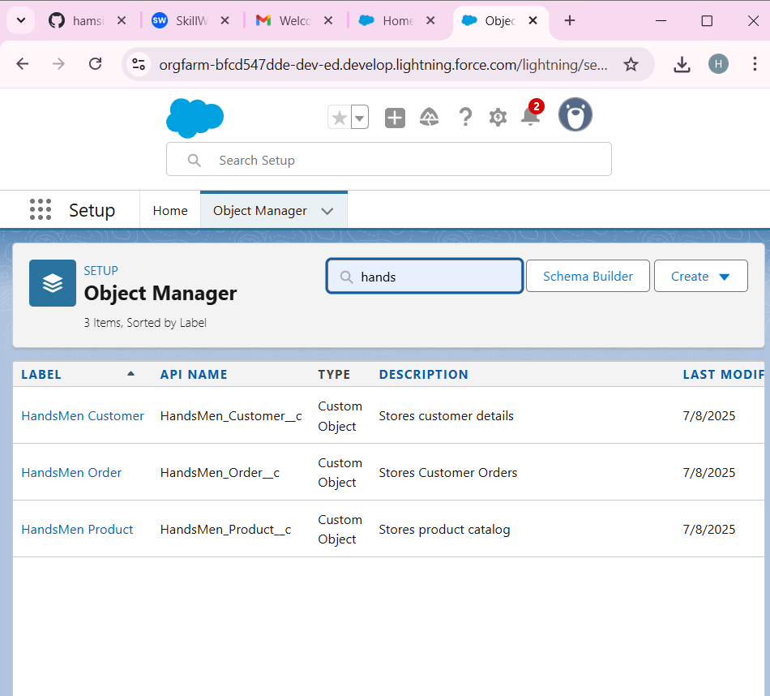

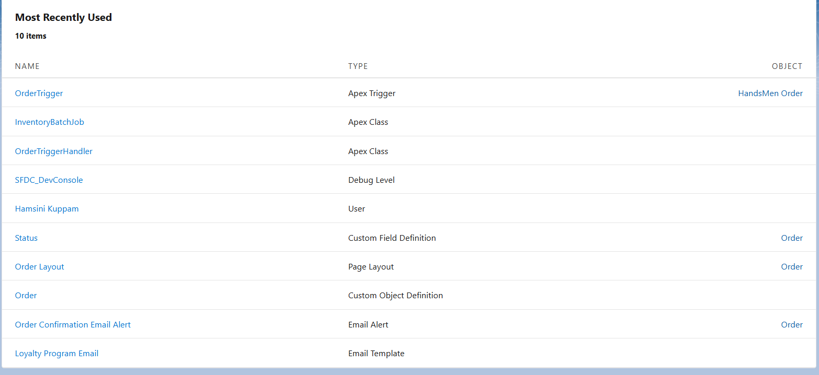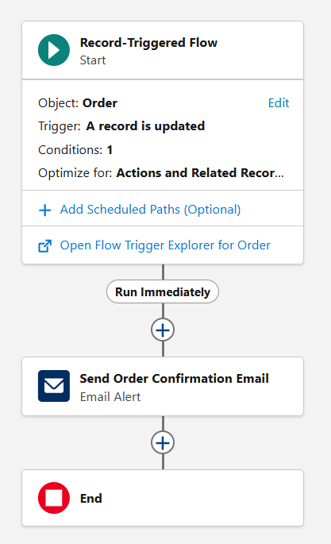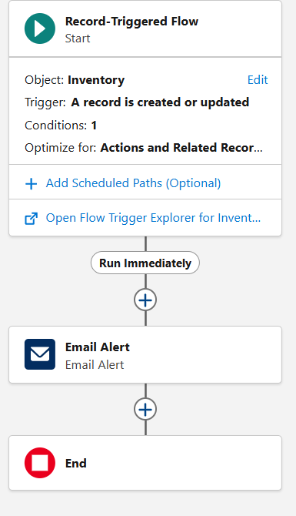

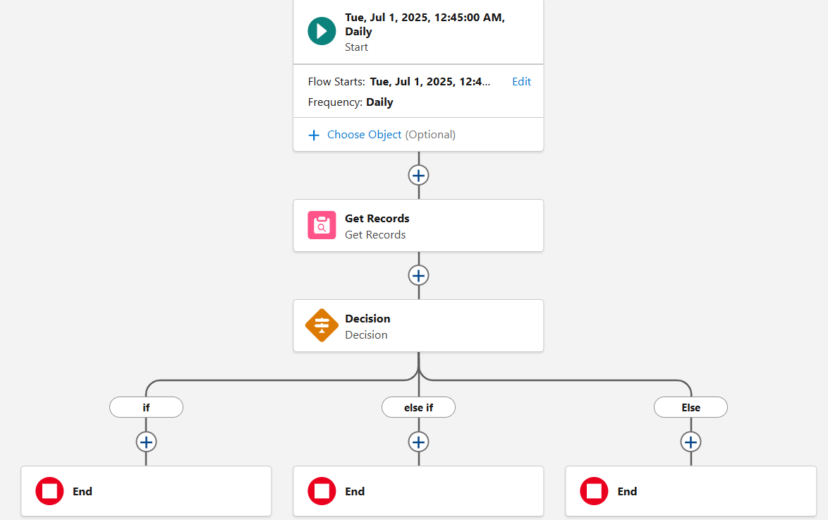

**Phase 5:Deployment, Documentation & Maintenance**

**Deployment Process**

* Moved everything from the sandbox to production using Change Sets.

**Ongoing Maintenance**

* Scheduled monitoring of batch jobs.
* Regular system checks to catch and fix issues early.
* Automated error alerts via email if something goes wrong.

**How We Handle Issues**

* Set up Salesforce Debug Logs and Flow error emails to help quickly diagnose problems.

**Conclusion**

The Salesforce CRM project for HandsMen Threads has laid a strong foundation for a smarter, more efficient business. From automating customer emails to helping the warehouse restock in time, every part of this system was designed with the goal of making work easier and customers happier. Looking ahead, the system can be expanded with features like AI-powered loyalty suggestions or a chatbot to support customers instantly.